**DB Restore from Azure SQL DB to onPrem and Vice Versa**

Let's divide these tasks into two main topics. The initial segment will delve into the process of deploying databases from local/on-premises environments to Azure SQL Database. Subsequently, the second topic will outline the steps involved in deploying databases from Azure SQL Database to an on-premises SQL server.

**Topic 1**

**Deploy Databases from Local/onPrem/ to Azure SQL Database!**

Step 1:

Go to the Database and right-click – choose ***Tasks*** – ***Deploy databases to Microsoft Azure SQL Database***

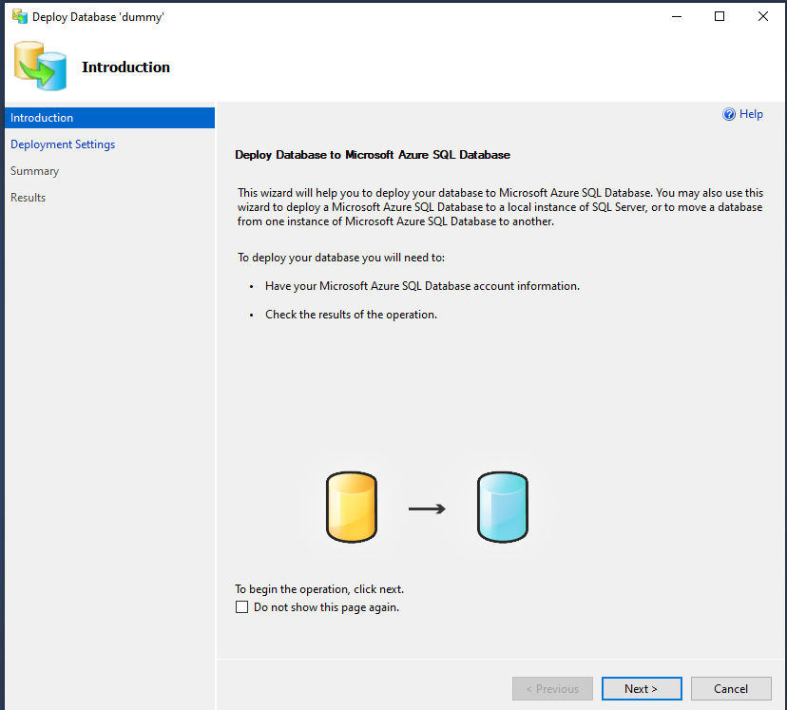



Step 2:

**Click next and create connection with Azure Logical SQL Server**

* Click **connect** – and choose the server and login credential.
* Insert the **database name.**
* Choose the database **edition**/and **setting**: basic, standard, etc. Beware that edition type will determine the cost and resiliency.
* Temporary file name (.bacpac) will be automatically assigned.

Step 3

**Finish the set up and verify!**

After clicking the finish button, onPrem SQL database is deployed as Azure SQL database.

**Verify the database is created in the logical server!**

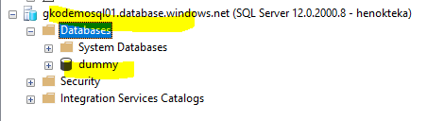

**Topic 2**

**2.0. Deploy Azure SQL Database to onPrem.**

**(Refreshing/restoring database from Azure SQL database to onPrem)**

Use the same steps in topic one i.e. SQL Database – task – *Deploy databases to Microsoft Azure SQL Database*

In connection, choose the onPrem serve.

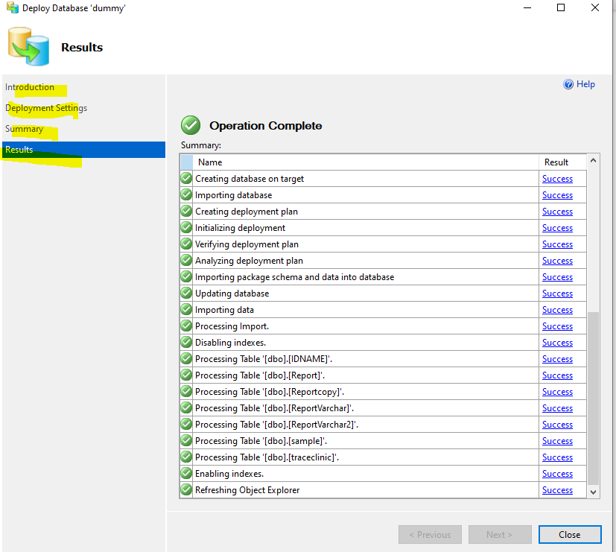



**Export (schema only)**

On azure sql db, export data+schema using export wizard



**NB: On 3,** the **advanced** option helps you to deploy specific tables if you don’t want to deploy the entire data/base.

NEXT

On onPrem server , use **import data-tier application** to deploy the database (data+schema). Then follow the wizard to import the data from where the bacpac file is stored in the above steps.

**Two options of deployment**

1. **Schema-only = Export Data-tier Application** (.bacpac file type)
2. **Schema + Data = Extract Data-tier Application** (.dacpac file type)

2

1

In the below example, we will restore both the **schema and data (hence we will choose “EXTRACT Data-tier Application”) – option 2**.

**Deploying Azure SQL database to onPrem involves two Grand Steps.**

1. Manual Backup of Azure SQL Database (if it is already backed up, you can go to Grand Step 2)

* This is to deploy from scratch. This step involves extracting DACPAC file to a folder.

1. Deploy the backed-up file to onPrem.

**Grand Step 1: Manual Backup**

Step 1:

Open Azure Logical SQL server and on the database click tasks – then **Extract Data-tier Application – click next**

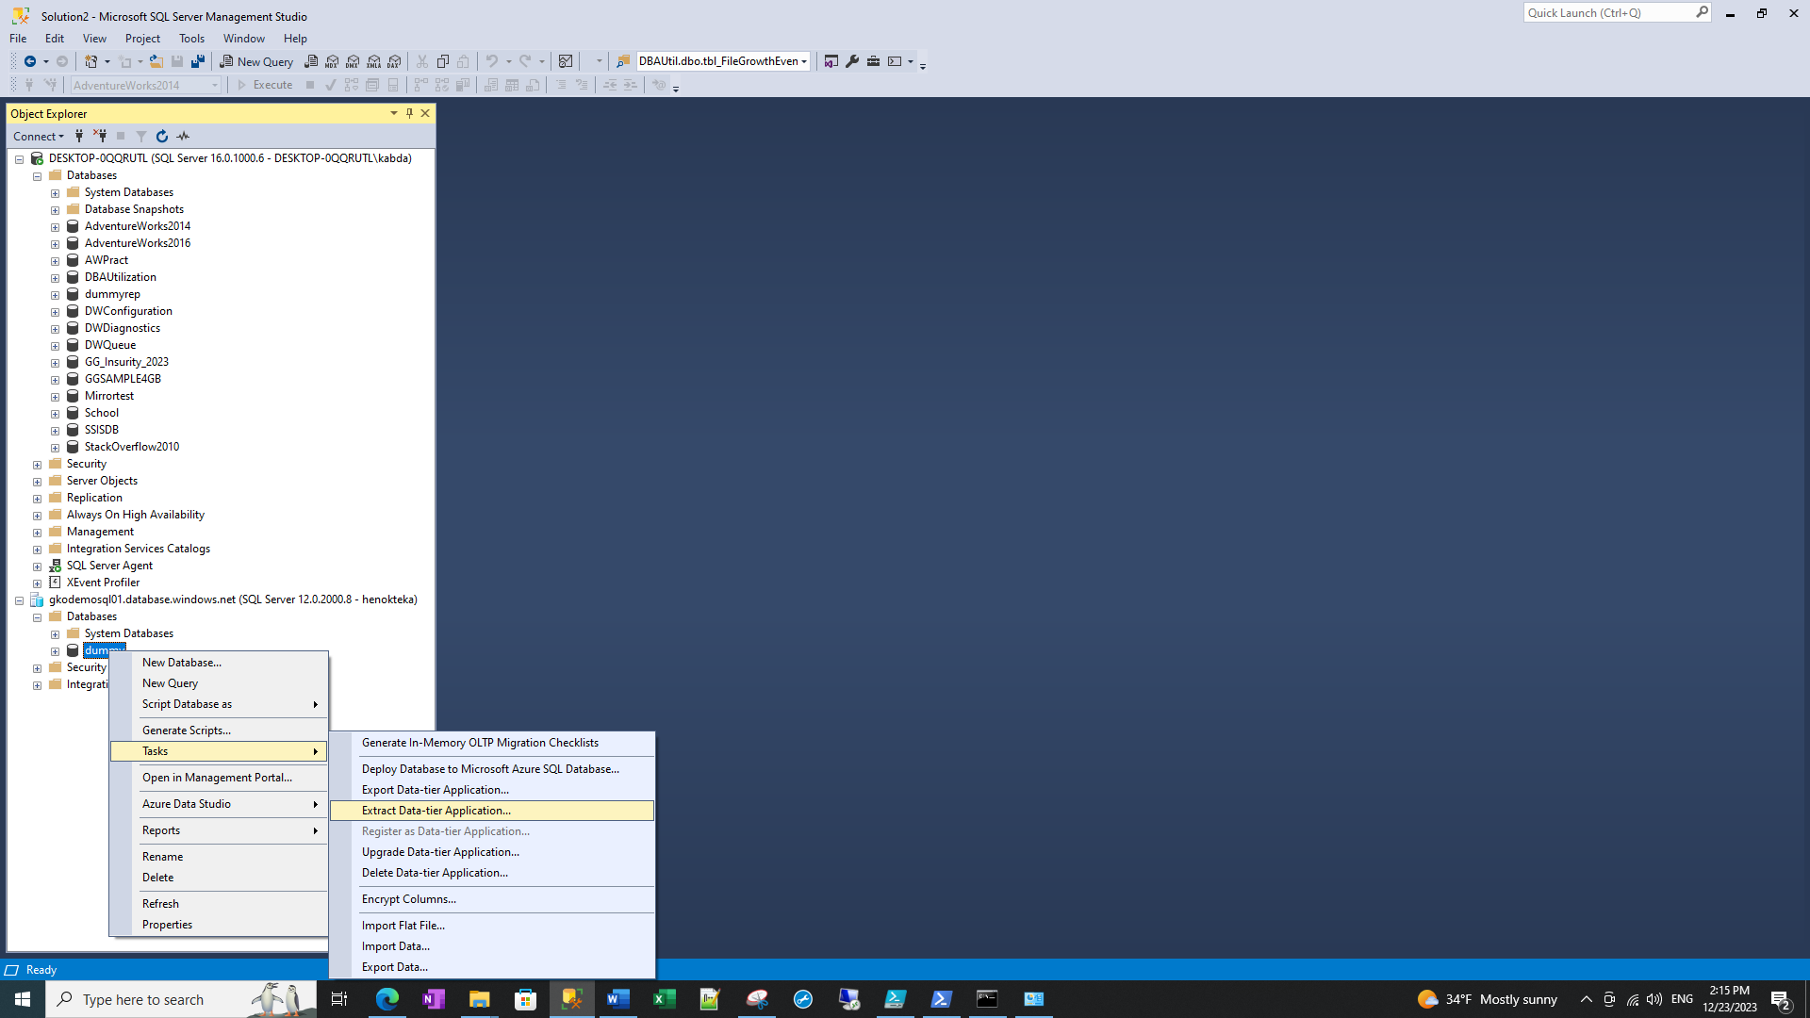

Step 2:

Set properties

* Choose the database name
* Choose the location

Step 3:

Click and validate.

Step 4:

**Build/Save the DAC PACkage**

This will take some time. Click finish after building.

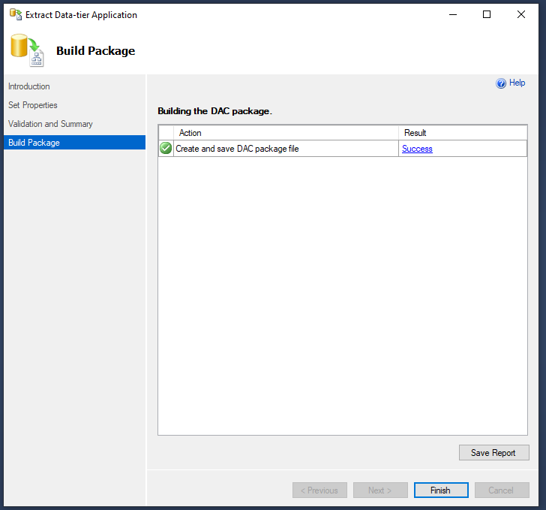

Step 5:

**Verify the DAC file is saved in the folder we chose.**

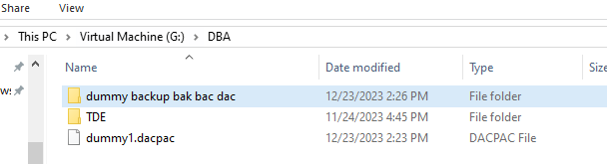

**Deploy/Restore from here!**

**Step 1:** On the onPrem/local instance, right click on databases and click **“Deploy Data-tier Application”. Click next**



**Step 2:** Browse and select the dacpac file – click next

**Step 3:** name the database and click next

**Step 4:** validate the **summary** and **deploy**.

step 5: **Finish** deploy and validate the creation of the database

